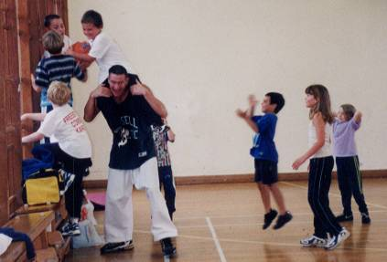

**SUMMER CAMP '2019**

Dear Parents,

I have pleasure in announcing that the “Freestyle Combat Summer Camp” will be held at **ASHLEY JUNIOR SCHOOL, Normans way, Ashley, New Milton. BH25 5FN. (School gym).**

The summer camp will consist of a mixture of karate and sports games, running three hours a day for five days and will be jammed packed with fun whilst offering some very exciting karate, such as sweeps, spinning kicks and agility techniques. There is no need to wear a karate suit as sportswear and trainers are more appropriate.

All students who attend the full five days will receive a certificate.

**ITINERARY FOR A TYPICAL DAY AT SUMMER CAMP.**

10.00 - 10.50am - Karate (pad work / spinning kicks)

10.50 - 11.00am - Waterbreak **(**Bringa water bottle**)**

11.00 - 12.00pm - Sports games (basketball / softball soccer, etc.)

12.00 - 12.15pm - Snack break (Bring light healthy snacks to eat)

12.15 - 12.45pm - Karate (various sweeps / agility training)

12.45 - 1.00pm - Karate Games (bulldog / dodge ball)



**COURSE DETAILS**

**Monday 5th August -** 10.00am - 1.00pm

**Tuesday 6th August -** 10.00am - 1.00pm

**Wednesday 7th August -** 10.00am - 1.00pm

**Thursday 8th August -** 10.00am - 1.00pm

**Friday 9th August -** 10.00am - 1.00pm

**COST - Students -** £60.00 **Friends -** £70.00 **Daily Rate -** £17.50

**Squad members –** £50.00 **Elite Squad -** Free

Please return the form below with **full payment** no later than

**Friday 26th July** as there are limited numbers for this camp.

**! Please make cheques payable to Freestyle Combat Karate.**

PLEASE FILL OUT AND RETURN BOTTOM HALF ONLY

FULL NAME:\_\_\_\_\_\_\_\_\_\_\_\_\_\_\_\_\_\_\_\_\_\_\_\_\_\_TEL:\_\_\_\_\_\_\_\_\_\_\_\_\_\_\_\_\_\_\_\_\_

BD00017_j0151325j0174551j0174539BD00010_BD00017_j0151325j0174539BD00010_j0174551I ENCLOSE THE SUM OF: £\_\_\_\_\_\_\_\_ Dates attending\_\_\_\_\_\_\_\_\_\_\_\_\_\_\_\_\_\_