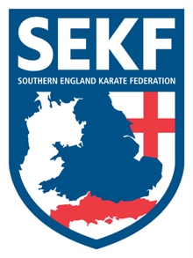
Special Karate Course

It is with great honour to announce that Willie Thomas 7th Dan and current England coach will be running a kumite course for the SEKF.
As a competitor Willie Thomas dominated his weight category winning gold medals at English, British, European and World level. At present Willie is the England Kumite Coach, passing on his wealth of knowledge and experience to our national squad.

This course will include all aspects of kumite training and is open to student’s green belt and above, plus squad members only.
There will be three sessions throughout the day. The first session is for student’s green belt above plus squad members, the 2nd session is for squad members only, whilst the last session is for Elite and A’ squad.

This Kumite course which has been part funded by the SEKF will be held on Saturday 8th October at Lymington Health & Leisure Centre, (Priestlands school gym), North street, SO41 8FZ

Registration - 9.45am – 9.55am Session one for green belt and above - 10.00am – 12.00pm
BREAK - 12.00pm – 12.30pm
Session two for squad members only - 12.30pm – 2.00pm
BREAK - 2.00pm – 2.30pm
Session three for Elite and A’ squad - 2.30pm – 4.00pm

COURSE COST - Session one only - £15.00
Squad members - £25.00

…..……………. please return slip below by Friday 7th October with full payment ……………...

STUDENT NAME: _______________________________ TEL: _____________
PLEASE TICK : SESSION ONE ONLY: £15.00_______________
SQUAD MEMBERS: £25.00_______________

SIGNED: ____________________________ TOTAL PAID: ________________
(Please make cheques payable to SEKF)

