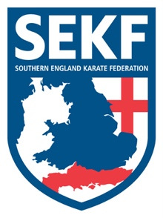
International Match

Squad Manager
Collin Rudkin
6Th Dan
Squad Coach Squad Captain
Danny Rudkin Patchouli Phillips
5th Dan 1st Dan

I have pleasure in announcing that the SEKF squad members who are blue belt and above are invited to an International Karate Match with Fran Salazar and his students from Spain on Saturday 21st January 2017 at Lymington Health & Leisure Centre (North Street, Lymington. SO41 8FZ).
The International karate match will consist of kata and kumite training followed by a mini competition. All competitors will receive a special medal for attending.

REGISTRATION - 12.15pm – 12.30pm
KATA TRAINING - 12.30pm – 2.30pm
BREAK - 2.30pm – 3.00pm
KUMITE TRAINING - 3.00pm – 5.00pm

COST - £20.00

Please contact me direct by email if you wish participate in this exciting event by Friday 16th December. Please note that all participants will receive help with pre-training for this event.

Please keep updated on squad events via the website and inform me direct as soon as possible if you are unable to attend any events. www.sekf.co.uk

Club Enquiries - collinrudkin@btinternet.com
Collin - 07966 303 585

