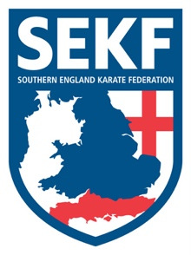
International Match

Squad Manager
Collin Rudkin
6Th Dan
Squad Coach Squad Captain
Danny Rudkin Louis Naraine
5th Dan 1st Dan

I have pleasure in announcing that the SEKF squad members who are blue belt and above, are invited to an International Karate Match with Fran Salazar and his students from Spain on Saturday 20th January 2018 at Lymington Health & Leisure Centre (North Street, Lymington. SO41 8FZ).

The International karate match will consist of both kata and kumite training. Lunch will be provided on the day and all students will receive a special medal for attending.

REGISTRATION - 12.45pm – 1.00pm
KATA TRAINING - 1.00pm – 2.30pm
LUNCH - 2.30pm – 3.30pm
KUMITE TRAINING - 3.30pm – 5.00pm
PHOTOS - 5.00pm – 5.30pm

COST - £20.00
ELITE SQUAD - £10.00

Please contact me direct by email if you wish to participate in this exciting event by Sunday 14th January. Payment is also due same day. (Please make cheques payable to the SEKF)

Please keep updated on squad events via the website and inform me direct as soon as possible if you are unable to attend any. www.sekf.co.uk

Club Enquiries - collinrudkin@gmail.com
Collin - 07966 303 585

