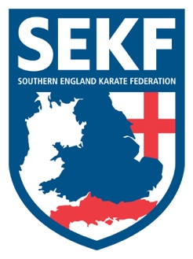
Newsletter
October 2020
Dear Parents and Students,

It was great to finally teach our students at the clubs after such a long time especially as they were so focused and enthusiastic.

Well, it seems like a long time ago now. However, in March just before the lockdown Sensei Collin Rudkin was presented with a Special Service to Sport Award by the New Forest Sports Council after helping our local children for over twenty-seven years to become confident, well rounded young athletes.

Coronavirus update: I am sure you are all aware of the governments’ new guidelines on track and trace and the new mobile App. This will undoubtably lead to more self-isolation cases over the coming weeks which could affect our students’ karate training.
Firstly, I cannot stress the importance of self-isolation if you have been in contact with someone who has been diagnosed with coronavirus as this will not only help to protect your family and friends, but it will also stop the possible spread to our Karate club.
If you need to self-isolate please inform Sensei Collin Rudkin direct.
We are still running a virtual zoom class once a week that you will be able to attend instead of your regular class whilst in isolation.

Please note, that if one of the coaching team needs to self-isolate we will endeavour to continue the classes. However, if we cannot get cover we will add extra virtual zoom classes for the isolation period.
All information and updates will be sent directly through the SEKF Information Only WhatsApp group….Let’s stay safe!

Saturday course for all SEKF students

There will be a special course on Saturday 10th October at New Milton Health & Leisure centre, Gore road. BH25 6RR).
This course will be a pre-grading therefore it is important to attend if you wish to grade the following week.

White & Green tag - 2.00pm - 3.00pm
Green to Purple tag - 3.00pm - 4.00pm
Purple belt & Above - 4.00pm - 5.00pm
Advanced course

There will be an advanced course for student’s Blue belt and above plus squad members only, to be held at New Milton Health & Leisure, Gore Road, BH25 6RR. This course will cover Knife defences and Advanced kata

Date: Sunday 11th October
Time: 11.30 – 1.30pm
Cost: ₤15.00

Please note: We intend to re-start running Saturday courses in the Poole area after half term.

If you have any queries, please do not hesitate to contact us.

Sensei Collin - 07966 303 585 Sensei Danny – 07813 329 710

collinrudkin@gmail.com www.sekf.co.uk

