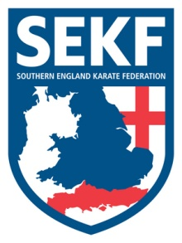

BRITISH INTERNATIONAL OPEN CHAMPIONSHIPS

DATE - Friday 26th / Saturday 27th / Sunday 28th September

VENUE - Emirates Arena, 1000 London road, Glasgow. G40 3HY

COST -
Hotel - £60.00
Petrol - Funded by the 100 club
Entry Fees - Funded by 100 club

TOTAL £60.00

Please confirm by Sunday 7th September with payment due Sunday 21st September

MEETING POINT

Rownhams Service Station – Friday 26th September at 9.30am sharp!

Return home – Sunday 28th September – 8.00pm – 9.00pm

REMEMBER TO BRING YOUR LICENCE AND WEAR YOUR TRACKSUIT

If parents wish to attend this competition or have any queries please contact me direct.

collinrudkin@btinternet.com
Collin - 01202 893 633 - 07966 303 585

