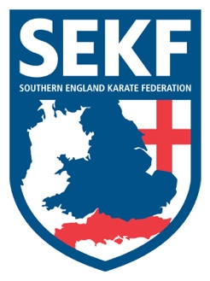
Newsletter June 2021
Well, it has been a great month of karate back at the clubs and nice to see so many enthusiastic students eagerly wanting to learn. Our pre-black belts are working very hard in preparation for the coveted black belt exam which is due to take place in July and our England elite athletes have trained to their limits in preparation for their 1st physical National squad session in over a year. Well done everyone!

Open squad session
There will be an Open Squad session on Sunday 13th June for students’ green belt & above to be held at New Milton Health & Leisure centre, (Gore road, BH25 6RR)
Time: 11.15am – 2.15pm Cost: £15.00

Saturday grading course for all students
There will be a special grading course on Saturday 19th June to be held at New Milton Health & Leisure Centre, (Gore Road, New Milton. BH25 6RR)
This course will be aimed at learning and perfecting Basics and fighting techniques for your next belt (or tag) and is vital if you wish to grade in July.

White belt to Orange tag - 1.00 – 1.50pm
Orange belt to Blue tag - 2.00 – 2.50pm
Blue belt to Brown tag - 3.00 – 3.50pm
Brown belt and above. - 4.00 - 5.00pm

Advanced Course
There will be an advanced course on Sunday 20th June for Blue belt & above to be held at New Milton Health and Leisure Centre. (Gore road, BH25 6RR). This course will cover some exciting, advanced work including advanced kicks, fighting techniques, pad work and knife defences. It is vital for students wishing to grade in July to attend.
Time: 11.15am – 1.15pm Cost: £15.00

If you would like further private tuition for the forthcoming grading in July, please do not hesitate to organise a date/time with Danny.

Sensei Collin - 07966 303 585 Sensei Danny - 07813 329 710
collinrudkin@gmail.com www.sekf.co.uk

