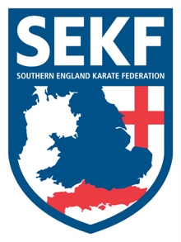
Kumite and Kata Weekend Course

SEKF Students Orange belt and above have an exciting opportunity to train alongside current England Kata Team member, James Scanlon and his students.

The SEKF Coaching Team will be jointly running the course which will consist of a Kumite and Kata session on both Saturday and Sunday.
Proceeds from this event will go to the SEKF International Fund to help finance our Elite K1 Athletes.

DATE - Saturday 5th / Sunday 6th October’ 2019

VENUE - New Milton Health & Leisure Centre, Gore Road. BH25 6RR

TRAINING - Saturday – Kumite training – 1.00pm – 2.45pm
Break - 2.45pm – 3.15pm
Kata training - 3.15pm - 5.00pm

Sunday - Kumite training - 11.30am – 12.45pm
Break - 12.45pm – 1.15pm
Kata training - 1.15pm - 2.30pm

COST - Saturday Only - £25.00
Saturday and Sunday - £35.00

Please return the form back with full payment by Friday 4th October
(Cheques made payable to the SEKF)

---------------------Please complete all sections and return bottom half only---------------------

Kumite and Kata Weekend

NAME: ______________________________ GRADE__________AGE:______

PLEASE TICK : Saturday training only: £25.00_______________
Sunday Training only: £25.00_______________
Both Days training : £35.00_________________

Please note the cost is £25.00 per day or £35.00 for both days

SIGNED: ____________________________ TOTAL PAID: ________________

