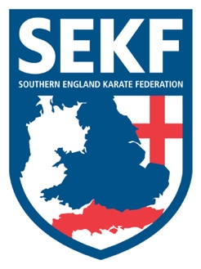
Newsletter
June ‘17
Congratulations to the SEKF kata squad for their recent success at the United Styles karate championships. Carla Rudkin-Guillen performed eight great kata’s, winning a silver medal in the -12 years category, followed by a bronze medal in the female cadet category -16 years. This was an amazing achievement for ten year old Carla, especially as she is the first SEKF student to achieve a medal in kata above her age group at national level.
Damla Kaya performed well in the Female cadet category -16 years, also winning a bronze medal. Ethan Stonton managed three good katas and was unfortunate not to medal, whilst poor Zak Smyth, slipped whilst jumping during his kata, which was a great disappointment to him, as his jumps are usually incredible.

The above article can be found on our website at www.sekf.co.uk
Please note, our website also covers all the Current News, Courses and Events.

Saturday course for Poole area students
There will be a special course on Saturday 17th June at the Ashdown Leisure Centre, (Adastral Rd, Canford Heath. BH17 8PY).
This course will be aimed at improving basics and fighting techniques for your next belt (tag) and is important if you wish to grade in July.

White belt to Green tag - 10.00am – 11.00am
Green belt & Above - 11.00am – 12.00pm

Saturday course for New Forest area students
There will be a special course on Saturday 17th June at New Milton Health & Leisure centre (Gore road, New Milton. BH25 6RR).
This course will be aimed at improving basics and fighting techniques for your next belt (tag) and is important if you wish to grade in July.

White & Red belts - 2.00pm - 3.00pm
Yellow to Green tags - 3.00pm - 4.00pm
Green belt & Above - 4.00pm - 5.00pm

ADVANCED COURSE
There will be an advanced course for Blue belt & above only, and Squad members, to be held at New Milton Health & Leisure Centre. Gore road, New Milton. BH25 6RR.

Date: Sunday 18th June Time: 11.00am – 1.00pm Cost: £15.00

CLUB ENQUIRIES - collinrudkin@gmail.com
COLLIN - 07966 303 585 / DANNY - 07813 329 710

