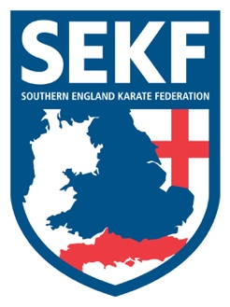
Newsletter
March ‘17
Firstly, we would like to welcome everyone back after the break

I am excited to announce that our two International hopefuls, Louis Naraine and Carla Rudkin-Guillen have been selected to compete at the USA Open Karate Championships in Las Vegas next month. They have both been training extremely hard over the last year, winning various titles from National to International level. Let’s all get behind them and inject our positive energy as I am sure they will appreciate it during their crucial last few weeks of pre-training.

Saturday course for Poole area students

There will be a special course on Saturday 4th March at the Ashdown Leisure Centre, Adastral Rd, Canford Heath. BH17 8RE.
This course will be aimed at basics and fighting techniques, therefore it is important to attend if you wish to grade in April

White belt to Green tag - 10.00am – 11.00am
Green belt & Above - 11.00am – 12.00pm

Saturday course for New Forest area students

There will be a special course on Saturday 4th March at New Milton Health & Leisure centre, Gore road. BH25 6RR).
This course will be aimed at basics and fighting techniques, therefore it is important to attend if you wish to grade in April

White & Red belts - 2.00pm - 3.00pm
Yellow to Green tags - 3.00pm - 4.00pm
Green belt & Above - 4.00pm - 5.00pm

Advanced course
There will be an advanced course for blue belt and above, plus squad members, to be held at New Milton Health and Leisure centre. (Gore road, New Milton. BH25 6RR).

Date: Sunday 5th March
Time: 11.00am – 1.00pm

Cost: £15.00

CLUB ENQUIRIES - collinrudkin@btinternet.com
COLLIN - 01202 893633
DANNY - 07813 329 710

