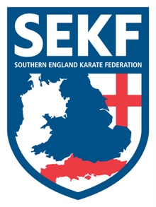
Youth Champions Course

I am excited to announce that our three Youth International Champions will be running a special Kata and Kumite course under the guidance of Danny and I, in order to fundraise for the World Ranking K1 competitions in 2019.

Carla Rudkin-Guillen – who is a member of the England Youth Kata Team is also Current Berlin International Open champion and Helsinki International Open champion. Carla has won a staggering 10 Gold, 9 Silver and 4 Bronze medals this year.
Elliott Lowman – is the current Lisbon International Open Kumite champion and English Champion
James Arnold – is also the current England Kumite Champion and Lisbon International Open silver medallist.

This special course will include exciting kata and kumite training and is open to students from Orange belt and above.
There will be three sessions throughout the day. The first session will cover the competition kata, Seienchin, whilst the 2nd session will cover Kumite drills including sweeps and Spinning kicks. The final session is for Brown belt and above only and will cover the exciting competition kata, Paiko

This Youth Champions Course will be held on Sunday 2nd December at Lymington Health & Leisure Centre, (Priestlands School Gym) North Street. SO41 8FZ

REGISTRATION - 11.45am – 11.55am Session one for Orange belt and above - 12.00pm – 1.15pm
BREAK - 1.15pm – 1.30pm
Session two for Orange belt and above - 1.30pm – 2.30pm
BREAK - 2.30pm – 2.45pm
Session three for Brown belt and above - 2.45pm – 4.00pm

We kindly request a minimum donation of £5.00 per session

…………please return slip below by Friday 30th November with full payment……………

STUDENT NAME: ______________________________GRADE: _____________
Please tick sessions attending: ONE: ______ TWO ______ THREE _______
Signed: _________________________ Donation for Athletes: £_______________ (Please make cheques payable to SEKF)

