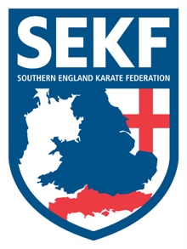
Covid-19 Update December 2020

Dear Parents / Students

Further to the recent government guidelines, I have pleasure in announcing that we will return to the clubs from Saturday 5th December and will continue to run our Wednesday on-line classes as before the National Lockdown. Unfortunately, we will not resume our Primary school classes until January 2021.
The fees for December will stay reduced at £37.50 and will include continued on-line training up to Friday 4th December. The Saturday course on the 5th December at New Milton Health & Leisure centre, training at any of the clubs until Friday 18th December and training online every Wednesday throughout December.
All students have their pre-lockdown classes guaranteed. However, if you wish to train an extra session at a different club than usual during December it is vital to contact Sensei Collin Rudkin beforehand to check availability. Mob: 07966 303 585

Weekly club details and Saturday course information will continue to be published on our website in the NEWS section
www.sekf.co.uk

Please make payment by Tuesday 1st December to the account details below, thanks.
Freestyle Combat Karate
50134759
20-68-79

We will be running the SEKF gradings at New Milton Health and Leisure as planned. However, we are waiting on hall confirmation. Once this is confirmed I will send out further information. Your patience is greatly appreciated during these difficult times.

Sensei Collin

