**EASTER CAMP**

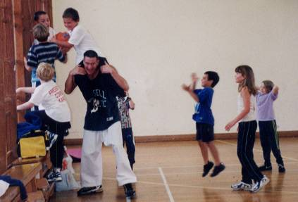

Dear Parents

I have pleasure in announcing that the “Freestyle Combat Easter Camp” will be held at **ASHLEY JUNIOR SCHOOL, Norman’s way, Ashley, New Milton. BH25 5FN. (School gym).**

The Easter camp will consist of a mixture of karate and sports games, running three hours a day for three days, and will be jammed packed with fun whilst learning some very exciting karate techniques, sweeps and spinning kicks.

There is no need to wear a karate suit as sportswear and trainers are perfect.

All students who attend the full three days will receive a certificate.

**ITINERARY FOR A TYPICAL DAY AT EASTER CAMP.**

10.00 - 10.50am - Karate (pad work or spinning kicks)

10.50 - 11.00am - Waterbreak **(**Bringa water bottle**)**

11.00 - 12.00pm - Sports games (basketball/softball soccer, etc.)

12.00 - 12.15pm - Snack break (Bring light healthy snacks to eat)

12.15 - 12.45pm - Karate (various sweeps or agility training)

12.45 - 1.00pm - Karate Games (Bulldog, dodge ball)



**COURSE DETAILS**

**Monday 9th April -** 10.00am - 1.00pm

**Tuesday 10th April -** 10.00am - 1.00pm

**Wednesday 11th April -** 10.00am - 1.00pm

**COST - Students -** £36 **Friends -** £40 **Daily Rate -** £15.00

**Elite squad –** Free **Squad members -** £30.00

Please return the form below with **full payment** no later than **Friday 6th April** as there are limited numbers for this camp.

PLEASE FILL OUT AND RETURN BOTTOM HALF ONLY

**------------------------------------------------------------------------------------------------**

FULL NAME:\_\_\_\_\_\_\_\_\_\_\_\_\_\_\_\_\_\_\_\_\_\_\_\_\_\_TEL:\_\_\_\_\_\_\_\_\_\_\_\_\_\_\_\_\_\_\_\_\_

BD00017_j0151325j0174551j0174539BD00010_BD00017_j0151325j0174539BD00010_j0174551I ENCLOSE THE SUM OF:£\_\_\_\_\_\_\_\_ Dates attending\_\_\_\_\_\_\_\_\_\_\_\_\_\_\_\_\_

**Please make cheques payable to Freestyle Combat Karate.**