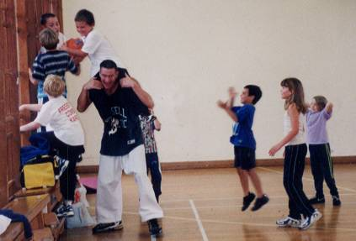

**SUMMER CAMP '2016**

Dear Parents,

I have pleasure in announcing that the “Freestyle Combat Summer Camp” will be held at **ASHLEY JUNIOR SCHOOL, Normans way, Ashley, New Milton. BH25 5FN. (School gym).**

The summer camp will consist of a mixture of Karate and sports games, running three hours a day for five days, and will be jammed packed with fun whilst learning some very exciting karate techniques, such as sweeps, spinning kicks and street defence.

**ITINERARY FOR A TYPICAL DAY AT SUMMER CAMP.**

10.00 - 10.45am - Karate (pad work and spinning kicks)

10.45 - 11.00am - Break

11.00 - 12.00pm - Sports games (basketball/softball soccer, etc.)

12.00 - 12.15pm - Break

12.15 - 12.45pm - Karate (various sweeps and street defence)

12.45 - 1.00pm - Karate Games (bulldog and dodge ball)



**COURSE DETAILS**

**Monday 8th August -** 10.00am - 1.00pm

**Tuesday 9th August -** 10.00am - 1.00pm

**Wednesday 10th August -** 10.00am - 1.00pm

**Thursday 11th August -** 10.00am - 1.00pm

**Friday 12th August -** 10.00am - 1.00pm

**COST - Students -** £50.00 **Friends -** £60.00 **Daily Rate -** £15.00

**Squad members –** £45.00 **Elite Squad -** Free

Please return the form below with **full payment** no later than

**Friday 29th July** as there are limited numbers for this camp.

**! Please make cheques payable to Freestyle Combat Karate.**

PLEASE FILL OUT AND RETURN BOTTOM HALF ONLY

**------------------------------------------------------------------------------------------------**

FULL NAME:\_\_\_\_\_\_\_\_\_\_\_\_\_\_\_\_\_\_\_\_\_\_\_\_\_\_TEL:\_\_\_\_\_\_\_\_\_\_\_\_\_\_\_\_\_\_\_\_\_

BD00017_j0151325j0174551j0174539BD00010_BD00017_j0151325j0174539BD00010_j0174551I ENCLOSE THE SUM OF: £\_\_\_\_\_\_\_\_ Dates attending\_\_\_\_\_\_\_\_\_\_\_\_\_\_\_\_\_\_