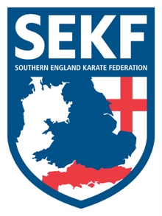
Special Karate Course

It is with great honour and excitement to announce that Fran Salazar (World Team Kata Champion) will be running a special Kata course for the SEKF.
Fran Salazar who represents Spain has dominated the World of Kata for many years winning numerous medals at National, European and World level.

This course will include advanced kata training drills and is open to student’s green belt and above, plus squad members only.
There will be three sessions throughout the day. The first session is for student’s green belt above plus squad members, the 2nd session where a new kata will be taught is for squad members only, whilst the last session is for the kata squad only.

This Kata course which has been part funded by the SEKF will be held on Sunday 13th November at New Milton Health & Leisure Centre, (Gore road, BH25 6RR)

Registration - 10.45am – 10.55am Session one for green belt and above - 11.00am – 12.45pm
BREAK - 12.45pm – 1.00pm
Session two for squad members only - 1.00pm – 2.30pm
BREAK - 2.30pm – 2.45pm
Session three for Kata squad only - 2.45pm – 4.00pm

COURSE COST - Session one only - £15.00
Squad members - £25.00

…..…………please return slip below by Saturday 12th November with full payment……………...

STUDENT NAME: _______________________________ TEL: _____________
PLEASE TICK : SESSION ONE ONLY: £15.00_______________
SQUAD MEMBERS: £25.00_______________

SIGNED: ____________________________ TOTAL PAID: ________________
(Please make cheques payable to SEKF)

