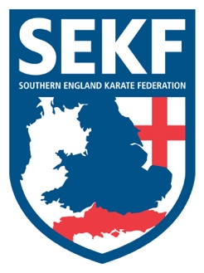
Newsletter November, 2016

Dear parents/Students

Congratulations to Louis Naraine and Carla Rudkin-Guillen who both won bronze medals in their respective categories at the recent CE International karate championships.
Well done to everyone who attended the Willie Thomas kumite course. Willie was impressed with the overall standard, especially our squad members.
Both articles are on the website along with the forthcoming events at www.sekf.co.uk

After our busy September and October, we have another jammed packed month of karate ahead of us, with the highlight being the Fran Salazar (World team kata champion) Kata course on Sunday 13th November. Not to be missed!

Saturday course for Poole area students

There will be a special course on Saturday 12th November at the Ashdown Leisure Centre, (Adastral Rd, Canford Heath. BH17 8PY).
This course will be aimed at learning and perfecting the basics and fighting techniques for your next belt (or tag) and is important if you wish to grade in December.

White to Green tag - 10.00am – 11.00am
Green Belt & Above - 11.00am – 12.00pm

Saturday course for New Forest area students

There will be a special course on Saturday 12th November at New Milton Health & Leisure Centre, (Gore Road, New Milton BH25 6RR).
This course will be aimed at learning and perfecting the basics and fighting techniques for your next belt (or tag) and is vital if you wish to grade in December.

White & Red belts - 2.00 – 3.00pm
Yellow belt to Green tags - 3.00 – 4.00pm
Green belt & Above - 4.00 – 5.00pm

If you have any queries, please do not hesitate to contact us:

COLLIN - collinrudkin@btinternet.com - 01202 893 633 / 07966 303585
DANNY - 07813 329 710

