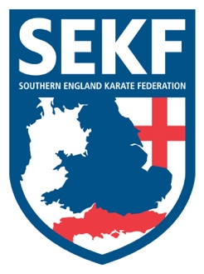
Newsletter April 2024

Dear parents and students,

Congratulations to everyone who graded before the Easter break especially Liz Zambeli, Oliver Cleaver, Lola McCafferty, Josh Corby and Daisy Dobson who all double graded. Well done!

Well done to the students who attended the exciting Easter karate Camp. Next Camp will be in August!

A massive congratulations to Carla Rudkin-Guillen after winning double Gold at the English Karate Championships and Christopher Cytus for winning Bronze. Great work!

Saturday grading course for all students
There will be a special grading course on Saturday 20th April to be held at New Milton Health & Leisure Centre, (Gore Road, New Milton. BH25 6RR)
This course will be aimed at learning the new kata for your next belt (or tag)

White & Red belts: - 10.00am – 11.00am
Yellow and Orange tag: - 11.00am – 12.00pm
Orange belt to blue tag. - 12.00pm – 1.00pm
Blue belt and above. - 1.00pm - 2.00pm

Advanced Course
There will be an advanced course on Sunday 21st April for students’ blue belt and above plus squad members to be held at New Milton Health and Leisure Centre. (Gore road, BH25 6RR). This course will cover some exciting, advanced work including advanced Kata and knife defences.

Time: 10.00am – 12.00pm Cost: £18.00
Please make payment to the SEKF – Account: 03807886 - Sort Code: 20-96-96

If you would like further private tuition in preparation for the next grading at the end of July, please do not hesitate to organise a date/time with Sensei Danny.

Sensei Collin - 07966 303 585 Sensei Danny - 07813 329 710
collinrudkin@gmail.com www.sekf.co.uk

